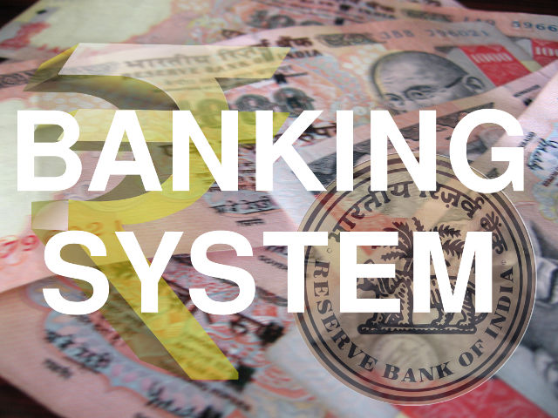
BANKING SYSTEM

1.BY USING ARRAY
2.BY USING INTERFACE
3.BY USING SCANNER CLASS
4.BY USING CONSTRUCTOR
5.BY USING FLAG

1.BY USING ARRAY

import java.io.*;
Sclass BankWork
{
final int max_limit=20;
final int min_limit=1;
final double min_bal=500;
private String name[]=new String[20];
private int accNo[]=new int[20];
private String accType[]=new String[20];
private double balAmt[]=new double[20];
static int totRec=0;
//constructor
BankWork()
{
for(int i=0;i<max_limit;i+ +)
{
name[i]="";
accNo[i]=0;
accType[i]="";
balAmt[i]=0.0;
}
}
TO ADD NEW RECORD
public void newEntry()
{
String str;
int acno;
double amt;
boolean permit;
permit=true;
if (totRec>max_limit)
{
System.out.println("\n\n\nSorry we cannot admit you in our bank...\n\n\n");
permit=false;
}

if(permit = true) //Allows to create new entry
{
totRec++; // Incrementing Total Record
System.out.println("\n\n\n=====RECORDING NEW ENTRY=====");
try{
accNo[totRec]=totRec; //Created AutoNumber to accNo so no invalid id occurs
System.out.println("Account Number : "+accNo[totRec]);

BufferedReader obj = new BufferedReader(new InputStreamReader(System.in));
System.out.print("Enter Name : ");
System.out.flush();
name[totRec]=obj.readLine();

System.out.print("Enter Account Type : ");
System.out.flush();
accType[totRec]=obj.readLine();

do
{
System.out.print("Enter Initial Amount to be deposited : ");
System.out.flush();
str=obj.readLine();
balAmt[totRec]=Double.parseDouble(str);
}while(balAmt[totRec]<min_bal); //Validation that minimun amount must be 500

System.out.println("\n\n\n");
}
catch(Exception e)
{}
}
}
//TO DISPLAY DETAILS OF RECORD
public void display()
{
String str;
int acno=0;
boolean valid=true;

System.out.println("\n\n=====DISPLAYING DETAILS OF CUSTOMER=====\n");
try{
BufferedReader obj = new BufferedReader(new InputStreamReader(System.in));
System.out.print("Enter Account number : ");
System.out.flush();
str=obj.readLine();
acno=Integer.parseInt(str);
if (acno<min_limit || acno>totRec) //To check whether accNo is valid or Not
{
System.out.println("\n\n\nInvalid Account Number \n\n");
valid=false;
}
if (valid==true)
{
System.out.println("\n\nAccount Number : "+accNo[acno]);
System.out.println("Name : "+name[acno]);
System.out.println("Account Type : "+accType[acno]);
System.out.println("Balance Amount : "+balAmt[acno]+"\n\n\n");
}
}
catch(Exception e)
{}
}
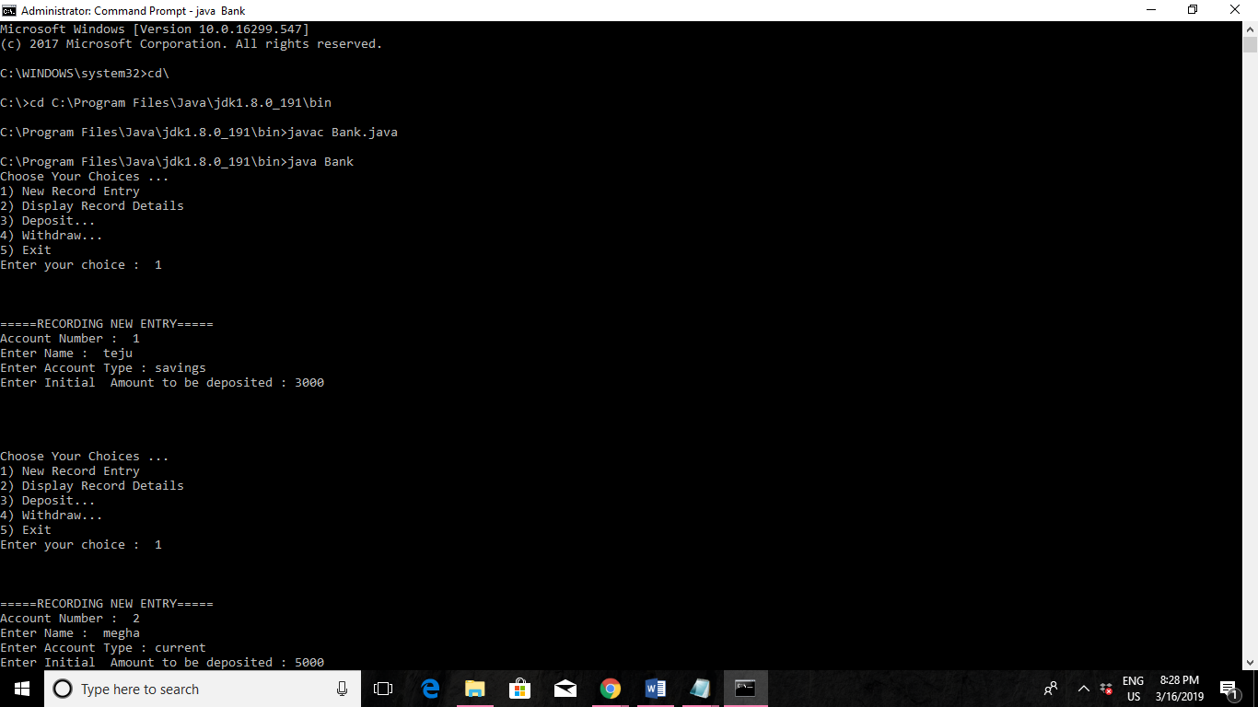

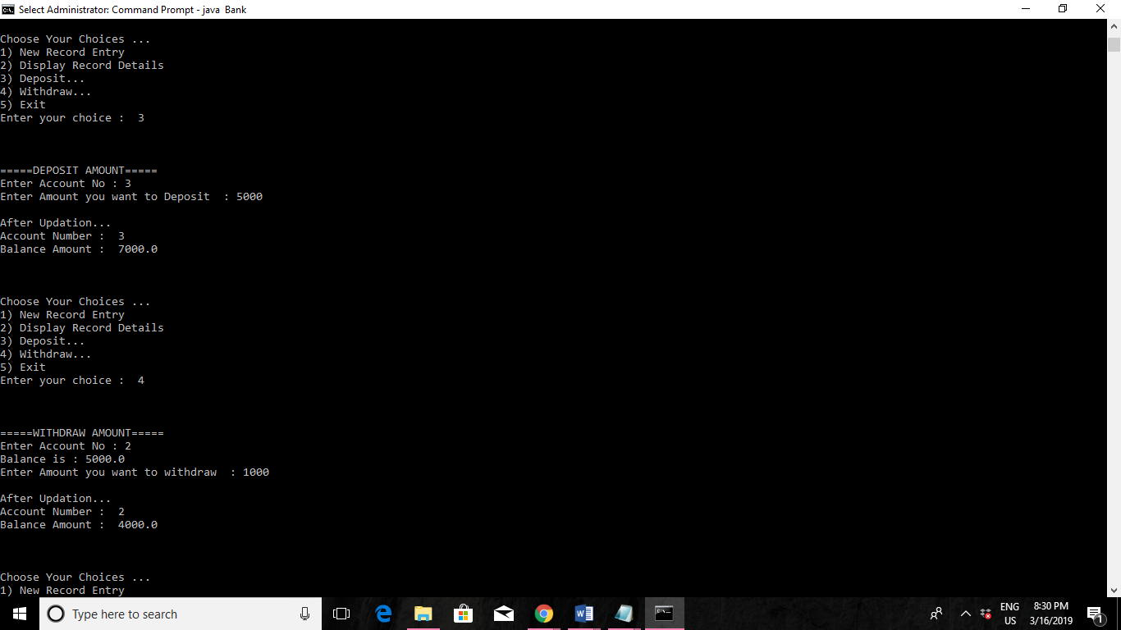
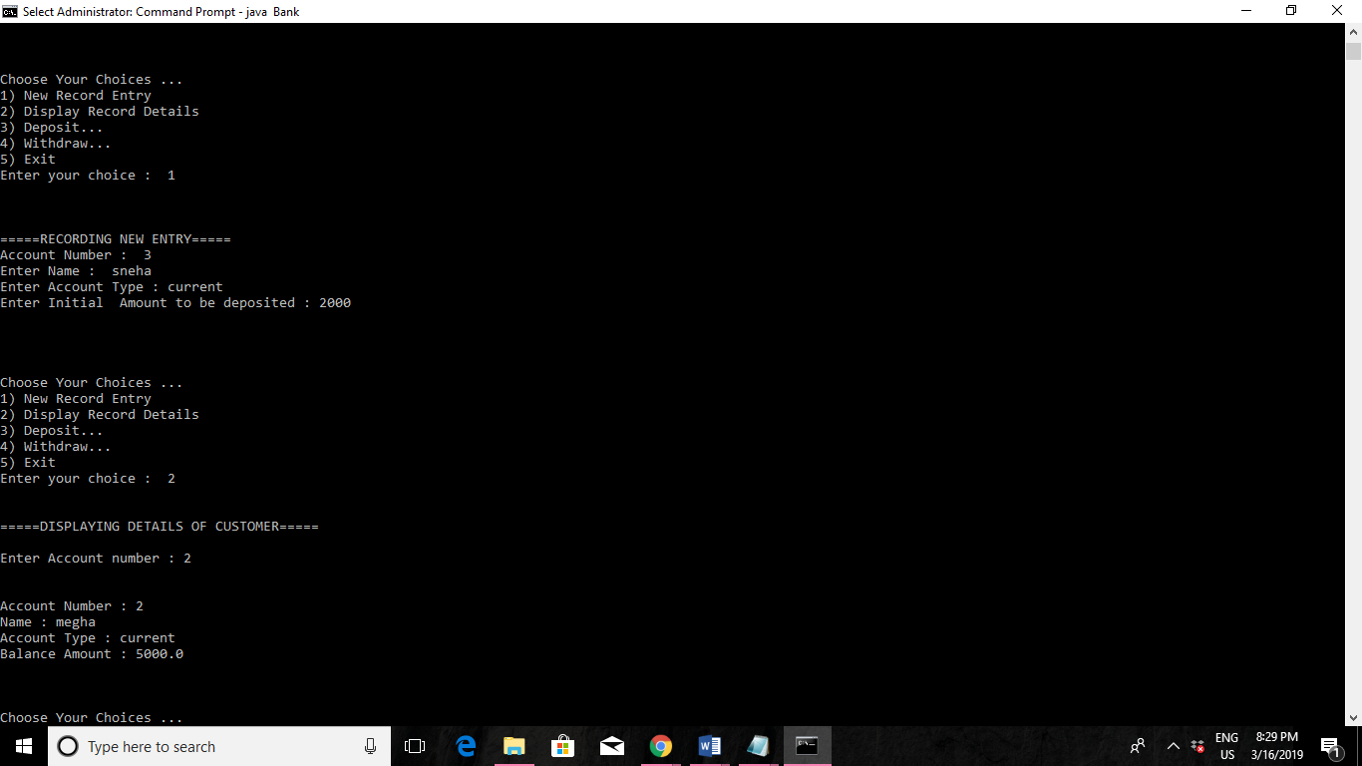
2.BY USING INTERFACE

class test
{
public static void main(String s[])
{
IAccount account = new HDFCAccount();

System.out.println("Transacting using HDFC Account");
transactOnAccount(account);
System.out.println();

account = new StateBankAccount();

System.out.println("Transacting using State Bank Account");
transactOnAccount(account);
}

public static void transactOnAccount(IAccount account)
{
System.out.println("------------------------------");
account.deposit(10000.0);
printBalance("depositing 10,000.0", account);
account.withdraw(2500.0);
printBalance("withdrawing 2,500.0", account);
account.withdraw(4100.0);
printBalance("withdrawing 4,100.0", account);
account.deposit(5000.0);
printBalance("depositing 5,000.0", account);
System.out.println("------------------------------");
}

public static void printBalance(String message, IAccount account)
{
System.out.println("The balance after " + message + " is " + account.getBalance() +".");
}

}

interface IAccount
{
double getBalance();

void deposit(double amount);

void withdraw(double amount);
}

class HDFCAccount implements IAccount
{
double deposits;
double withdrawals;

public double getBalance()
{
return deposits - withdrawals;
}

public void deposit(double amount)
{
deposits += amount;
}

public void withdraw(double amount)
{
withdrawals += amount;
}
}

class StateBankAccount implements IAccount
{
double balance;

public double getBalance()
{
return balance;
}

public void deposit(double amount)
{
balance += amount;
}

public void withdraw(double amount)
{
balance -= amount;
}
}

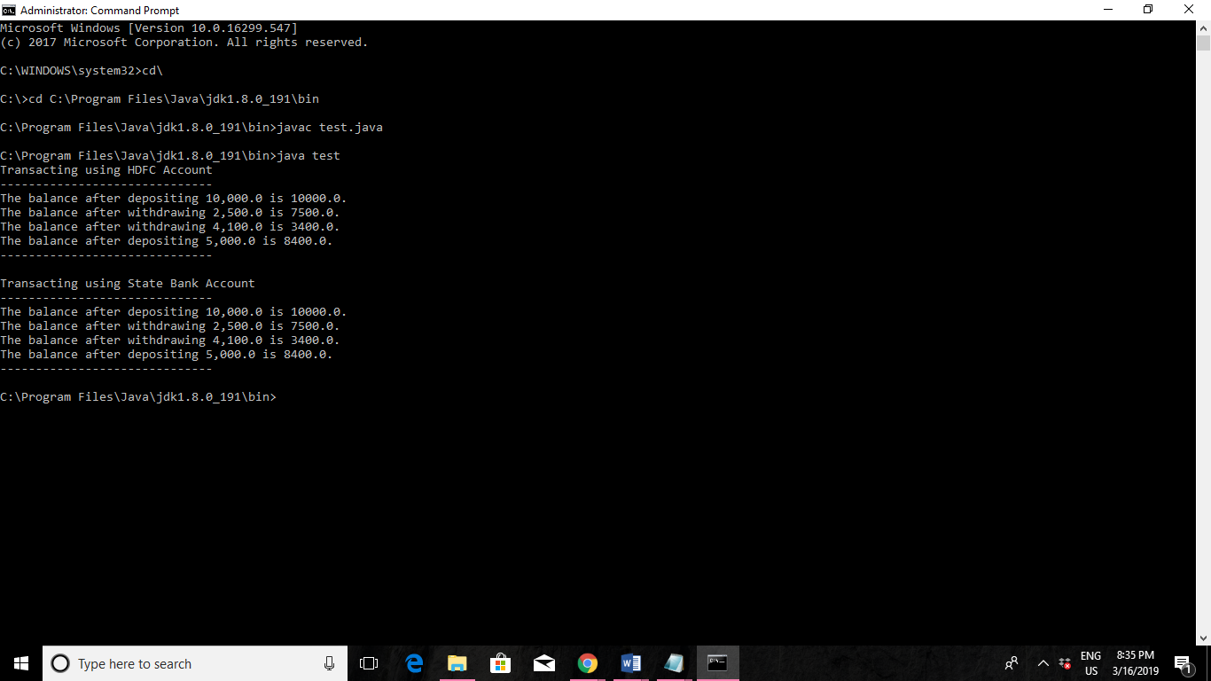

3.BY USING SCANNER CLASS

import java.util.*;
class bankInternal {
int ac;
float bal, amt;
Scanner get = new Scanner(System.in);
void getdetails()
{
System.out.print(“Enter Account Number:”);
ac = get.nextInt();
System.out.println();
System.out.print(“Enter Initial Balance:”);
bal = get.nextFloat();
}
void deposit()
{
System.out.println();
System.out.print(“Enter Amount:”);
amt = get.nextInt();
bal = bal+amt;
System.out.println(“Success! Amount deposited. Balance Available:”+bal);
}

void withdraw()
{
System.out.println();
System.out.print(“Enter Amount:”);
amt = get.nextInt();
if(amt>bal)
{
System.out.println(“Insufficient Funds!!”);
}
else
{
bal = bal-amt;
System.out.println(“Amount Withdrawn! Available Balance:”+bal);
}
}

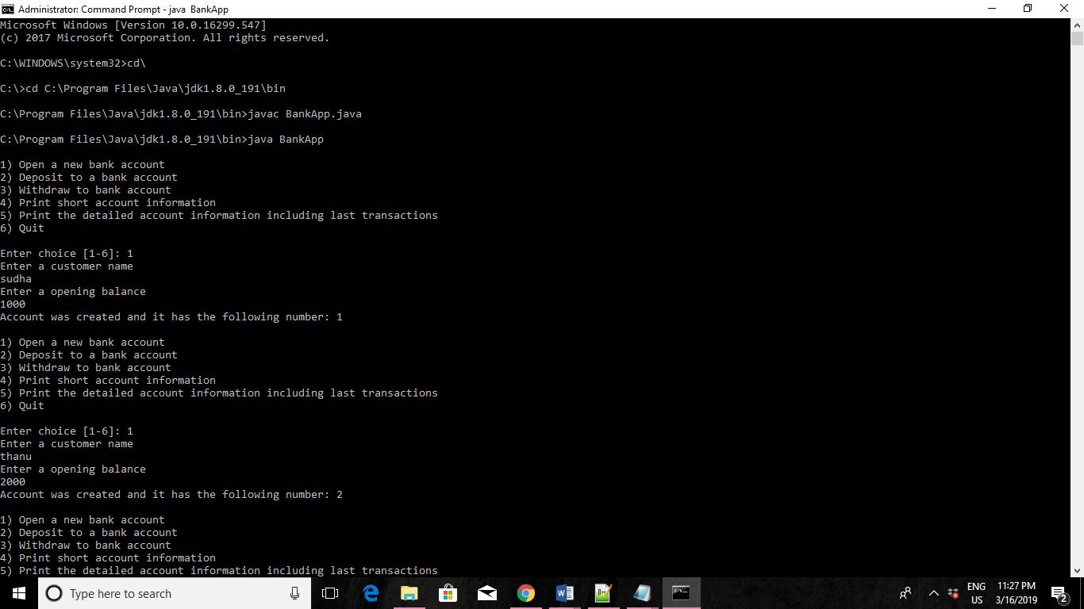

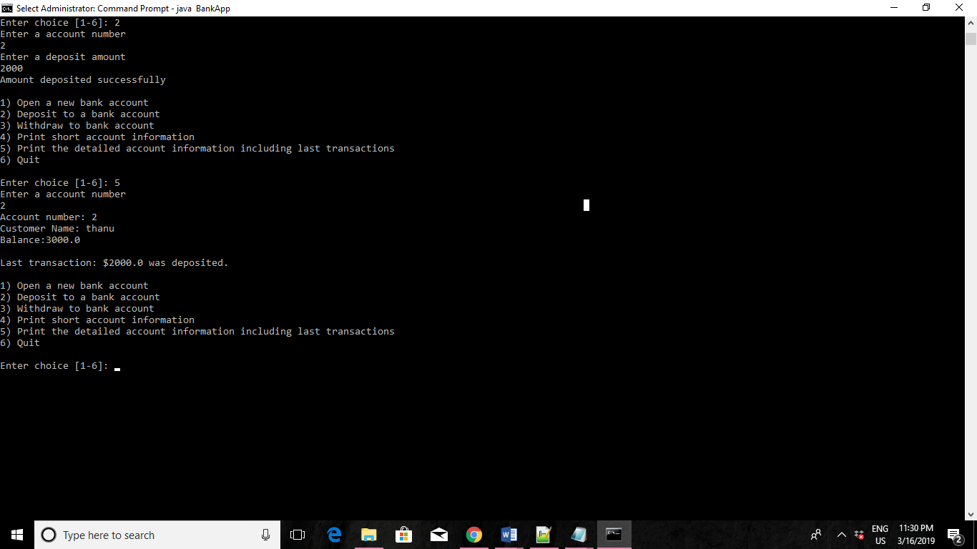

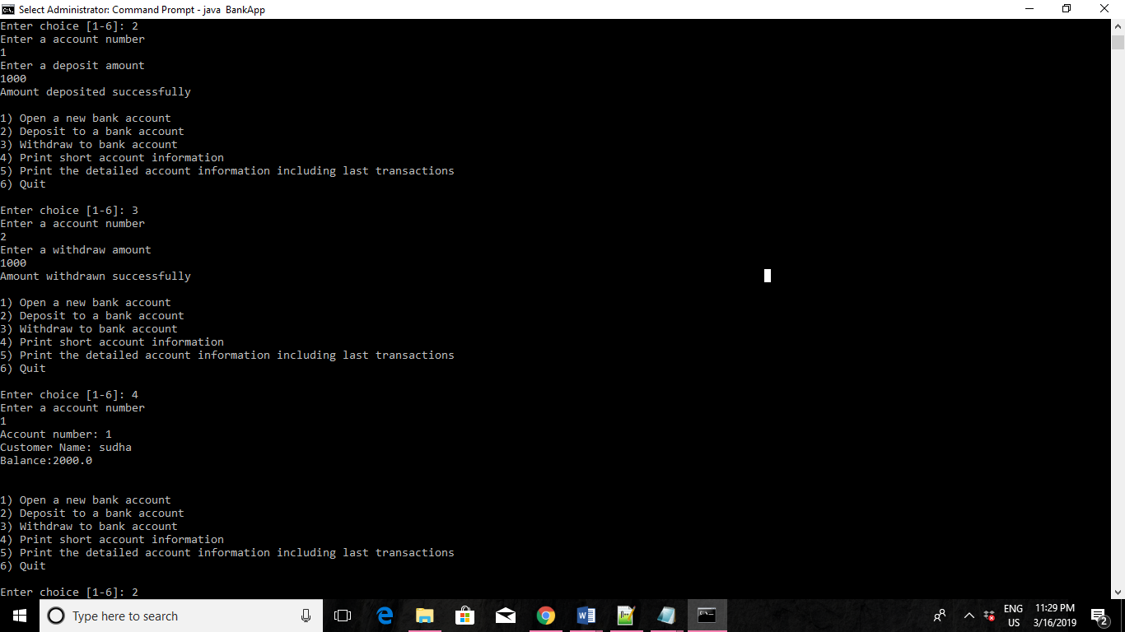

4.BY USING CONSTRUCTOR

import java.io.DataInputStream;
class Bank
{
String name,type;
int acno,bal,wit,dep;

// To assign initial values by constructor
Bank(String n, String t,int b)
{
name=n;
type=t;
bal=b;
}
// To deposit an amount
void deposit()
{
//creating object of class DataInputStream.
DataInputStream in = new DataInputStream(System.in);
try
{ System.out.print(" Enter amt to deposit : ");
dep = Integer.parseInt(in.readLine());

bal=bal+dep;
show();
}
catch(Exception e) { System.out.println("I/O Error"); }
}

// To withdraw an amount after checking balance
void withdraw()
{

//creating object of class DataInputStream.
DataInputStream in = new DataInputStream(System.in);

try
{

System.out.println("\nEnter amt to withdraw : ");
wit = Integer.parseInt(in.readLine());
if(bal-wit>=500)
bal=bal-wit;
else
System.out.println("You cannot withdraw....");
show();
}

catch(Exception e) { System.out.println("I/O Error"); }
}

// To display the name and balance
void show()
{
System.out.println("\nDepositor name :"+name);
System.out.println("Type of Account :"+type);
System.out.println("Balance :"+bal);
}
}

class P25
{
public static void main(String args[ ])
{
int choice;
int ans;
Bank b1=new Bank("Stavan","Saving",50000); //providing initial value by constructor

b1.show();

//creating object of class DataInputStream.
DataInputStream in = new DataInputStream(System.in);

try
{
do
{
System.out.println("\n1. Deposit");
System.out.println("2. Withdraw");
System.out.print("Enter your choice (1/2) :");
choice = Integer.parseInt(in.readLine());

if(choice ==1)
b1.deposit();
if(choice ==2)
b1.withdraw();
System.out.println("\nDo you want to continue ?(1: yes /0 : No)");
ans = Integer.parseInt(in.readLine());
}while(ans==1);
}
catch(Exception e) { System.out.println("I/O Error"); }
}}

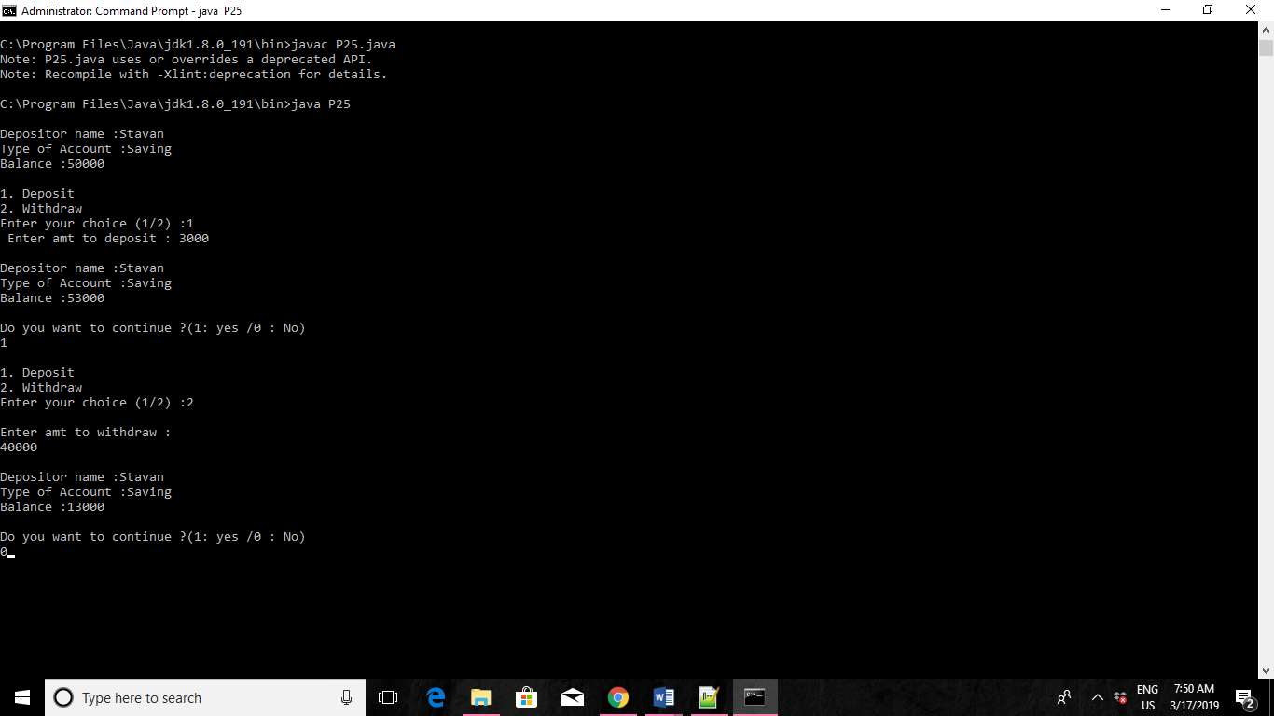

5.BY USING FLAG

import java.util.*;
class bankInternal {
int ac;
float bal, amt;
Scanner get = new Scanner(System.in);
void getdetails()
{
System.out.print("Enter Account Number:");
ac = get.nextInt();
System.out.println();
System.out.print("Enter Initial Balance:");
bal = get.nextFloat();
}
void deposit()
{
System.out.println();
System.out.print("Enter Amount:");
amt = get.nextInt();
bal = bal+amt;
System.out.println("Success! Amount deposited. Balance Available:"+bal);
}

void withdraw()
{
System.out.println();
System.out.print("Enter Amount:");
amt = get.nextInt();
if(amt>bal)
{
System.out.println("Insufficient Funds!!");
}
else
{
bal = bal-amt;
System.out.println("Amount Withdrawn! Available Balance:"+bal);
}
}

void balchk()
{
System.out.println("Balance available in Account Number "+ac+" is: "+bal);
}
}

class bankArray {
public static void main(String args[])
{
boolean a=true;
int acno, flag;
Scanner in = new Scanner(System.in);
bankInternal obj[] = new bankInternal[100];
for(int i=0;i<3;i++)
{
obj[i] = new bankInternal();
}
int ch;
do
{
flag=1;
//Reset flag value. System.out.println("1.Add Account"+"\n"+"2.Deposit"+"\n"+"3.Withdraw"+"\n"+"4.Check Balance"+"\n"+"5.Exit");
System.out.println(); System.out.print("Enter your Choice:"); ch = in.nextInt(); switch(ch)

{
case 1:for(int i=0;i<3;i++)
{
obj[i].getdetails();
}
break;
case 2: System.out.println("Enter Account Number:");
acno = in.nextInt();
for(int i=0;i<3;i++)
{
if(acno == obj[i].ac)
{
obj[i].deposit();
flag=0;
}
}
if(flag==1)
{
System.out.println("Account number not found!!"+"\n");
}
break;
case 3: System.out.println("Enter Account Number:");
acno = in.nextInt();
for(int i=0;i<3;i++)
{
if(acno == obj[i].ac)
{
obj[i].withdraw();
flag=0;
}
}
if(flag==1)
{
System.out.println("Account number not found!!"+"\n");
}
break;
case 4: System.out.println("Enter Account Number:");
acno = in.nextInt();
for(int i=0;i<3;i++)
{
if(acno == obj[i].ac)
{
obj[i].balchk();
flag=0;
}
}
if(flag==1)
{
System.out.println("Account number not found!!"+"\n");
}
break;
case 5: System.exit(0);
default: System.out.println("Enter a valid Option!"+"\n\n");
}
}
while(a);
}



